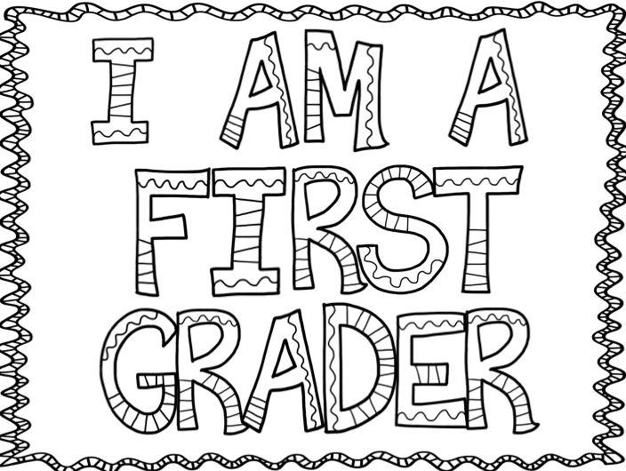

Welcome Back,
Hi, I am so glad you are going to be in my classroom! We are going to have so much fun learning this school year. I hope you are ready to help me this year to lead this class to excellence! I am going to need your help to make everyone feel safe and welcome in our class each and every day! Our challenge this year, as a classroom goal, is to see how many people we can show random acts of kindness so we can see our friend’s, staff and teachers smile daily.

I hope you can come to our open house! It is on August 28st from 6:30-7:3 0. Get ready to have an o”fish”al treat, see the new classroom and tour the school with your family. Don’t forget to check out the playground and visit all your special rooms (Stem, Library, Art, Computers & PE)

On our first day of school is Tuesday, September 3rd as a ½ day. During this time, we will have a class community breakfast, get name tags, play, have community circle time, meet new friends, learn some rules, find out where everything is in your new classroom and school, sing some songs, read a story and see the playground. You will need to bring a water bottle clearly labeled with your name. Also come with a backpack to school each day with your folder, a small healthy snack and drink for our daily snack time and a clean pair of tennis shoes to keep in your locker for P.E./gym. Please label all classroom items, jackets, gym shoes, lunch boxes, snack boxes, pencil box etc. I will send water bottles home each Friday to be washed. Tentative special schedule:
Monday- Art
Tuesday- Computers
(You need a pr. Of headphones: labeled with your child’s name in a ziplock bag for your child in computers)
Wednesday- Library & PE/Gym
(You must have a clean pair of shoes to leave at school for Gym)
Thursday-STEM
Friday-Music
Please email me at twhiting@mapsk12.org anytime! Can’t wait to see you!
Please visit my Weebly for supply list, yearly calendar of events, lots of fun interactive learning games and for all the calendars, events and newsletters. It’s a fun place to be!
http://tinawhiting.weebly.com/
See You Soon!!!!! Room 105 at the bottom of ramp to the right/north (Right across from Mr. Hedrick’s STEM classroom)
Enjoy the remainder of your summer!!!
Your Teacher, Mrs. Whiting ☺
Supply List
You can find the school calendar located on the Montague web site.
MAPS school calendar ; District Calendar

