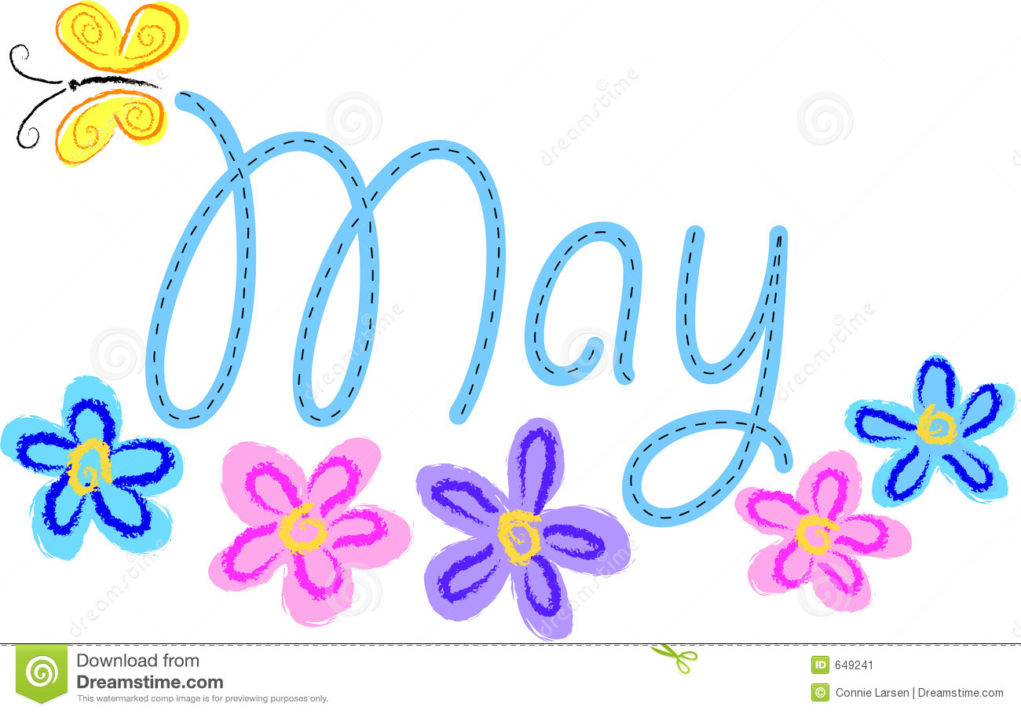
We hope you had a wonderful Mother’s Day weekend and enjoyed all the treasures your child made for you during our week of thanking our mothers. They worked so hard!
Upcoming events:
May 17th walking to HS for animal day at 11:40
May 19th time line due with event and or picture each year and weight and height for each year.
May 27th -No School Memorial Day
May 30th Snell Gardens trip planting trip 11:50-2:10
June 7th Field Day
June 11th & 12^{2h} ½ days end of school Tentative dates 13th and 14th ½ days. Awaiting the state letter of forgiveness.

Reading:
Chapter book for May: We are ½ way through Charlie and the Chocolate Factory
Students are reading both fiction and nonfiction at their ability level daily. They are writing at least 3 facts about their nonfiction text and writing character, setting, problem and solution with connection for a fictional piece. We read independently 20 mins each morning. We read with a partner 5-10 mins each day. We listen to stories and answer questions and make connections daily. We are making text to text, text to self and text to world connections. Just ask us!
We are continuing our vowel teams and spelling combinations for spelling words tests and weekly tests and comprehension weekly tests on Fridays.
Come visit during reading time 9-10:45
Writing: Our focus this week is on space and reviewing plant life from last week and what can plants could live in space. Our focus daily is on the difference between narrative, opinion and personal expertise fact writing. We know we can use the same topic and write all genres about out topic.
Writing Time: 11:40-12:30
*Our new writing unit will consist of students knowing/reflecting on the difference between: Narrative/Opinion/Personal Expertise:
What you can do at home: Can you find a butterfly or a worm to bring to school? We will release after observations.
Science: WE are wrapping up our animal life unit with Mr. Hedrick’s Stem related activities to this unit. This has worked nicely with our writing units to research and explore for all genres of writing.
What you can do at home: Make observations of animal life, draw the animals, use teaching labels to focus on the animal’s attributes. Bring your piece into class to publish and share your great writing abilities.
Come be a scientist/naturalist from 12:30-1.
Mathematics:
We are problem solving and coding this month in math to find the hidden numbers.
We are analyzing data for our gliders and flight plans. This works nicely with our space unit in treasures.
How you can help at home: Ask your child what is 10 more than any number, ten less, one more one less. We are solving our coding and problem solves with tracing 10 more 10 less and one more one less as a series of events. I am thinking of a number that is 10 less than 32 and one more. I am thinking of a number that is 10 more than 100 and one less. Have fun number line jumping to find the missing number.
Make a glider at home and have a flight plan and family contest for distance.
Come visit during math time and see our learning. 1:15-2:15
We are finding flexibility with numbers, symmetry and conceptual understanding in this unit.
Classroom Needs: Clorox wipes, please send in a water bottle for your child to use each week.
Check out the class Weebly! http://tinawhiting.weebly.com/
Mrs. Whiting

