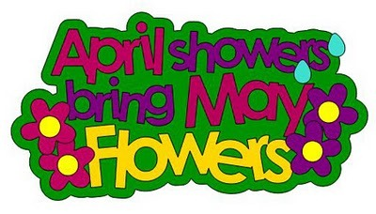

Upcoming events:
May 27th -No School Memorial Day
May 28th Snell Gardens trip
June 7th Field Day
June 13th & 14th ½ day Tentative Last day of school (To make up for missed snow/ice days that the state did not excuse as of yet.) We are allowed 6 for the school year. The state waved an extra 3, but we still have 2 to make up.

Reading:
Chapter book for April: Charlie and the Chocolate Factory
Students are reading both fiction and nonfiction at their ability level daily. They are writing at least 3 facts about their nonfiction text and writing character, setting, problem and solution with connection for a fictional piece. We read independently 20 mins each morning. We read with a partner 5-10 mins each day. We listen to stories and answer questions and make connections daily. We are making text to text, text to self and text to world connections. Just ask us!
We are continuing our vowel teams and spelling combinations for spelling words tests and weekly tests and comprehension weekly tests on Fridays.
Come visit during reading time 9-10:45
Writing: We have studied insects, birds and rabbits so far in our science writing unit as naturalist writers. We will flip our focus back to insects to focus on our butterflies and metamorphosis transition and relating that to what other insects have this process.
Writing Time: 11:40-12:30
*Our new writing unit will consist of students knowing/reflecting on the difference between: Narrative/Opinion/Personal Expertise:
What you can do at home: Can you find a butterfly or a worm to bring to school? We will release after observations.
Science: We are studying all animal life but focusing each week on a species. insects/egg, larva, metamorphosis. Birds/egg; Rabbits, Caterpillar to butterfly. Making connection to what we learned on our field trip for a story experience. Then next week we will move to worms and frogs.
What you can do at home: Make observations of animal life, draw the animals, use teaching labels to focus on the animal’s attributes.
Come be a scientist/naturalist from 12:30-1.
Mathematics:
Our focus is on coins this week. Trading coins for same amount using different coins. I have a quarter what can you trade me what is worth the same amount? We are estimating how many in a jar and determining if our guess/estimate is a “good” estimate. We are focusing on before and after a number from 1-120.
How you can help at home: Numbers before and after. As you are driving: Ask your child what comes before and after a number. My number is 54 what comes before? What comes after? If this is difficult: remind your child that before is less and after is more. If this is easy ask: What is 10 more, what is 10 less. Give any number and ask your child to go up by 10s. My number is 23 go up by 10s until I tell you to stop. My number is 120 go back by 10s until I tell you to stop. My number is 55 go up by 5 now go back by 5s. This helps your child with addition and subtraction fluency.
Come visit during math time and see our learning. 1:15-2:15
We are finding flexibility with numbers, symmetry and conceptual understanding in this unit.
Classroom Needs: Clorox wipes, please send in a water bottle for your child to use each week.
Check out the class Weebly! http://tinawhiting.weebly.com/
Mrs. Whiting

