April Showers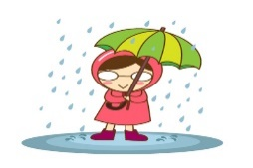 Bring.. May Flowers 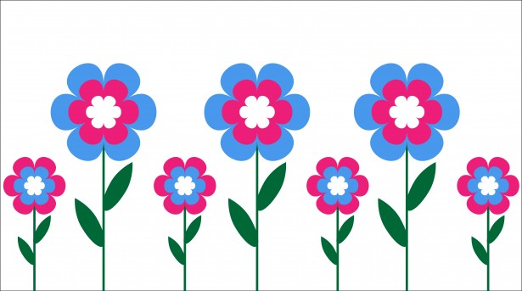
Upcoming events:
April 12th Chaperone for and money due of 9.00 due by April 12th. Otherwise it is 14.50 at the door.
April 19 Grand Rapids Fredrick Meijer Gardens Student bus leaves 8:40-2:25 returns
May 27th -No School Memorial Day
June 11th & 12th ½ day Last day of school

Reading:
Charlie and the Chocolate Factory
Students are reading both fiction and nonfiction at their ability level daily. They are writing at least 3 facts about their nonfiction text and writing character, setting, problem and solution with connection for a fictional piece. We read independently 20 mins each morning. We read with a partner 5-10 mins each day. We listen to stories and answer questions and make connections daily. We are making text to text, text to self and text to world connections. Just ask us!
Come visit during reading time 9-10:45
Writing: We are focusing on insects this week with the opening of our science unit. We are writing all genres of writing and knowing the difference in each: opinion, narrative and informational and we know what the success criteria is for each type of writing. Just ask us!
Writing Time: 11:40-12:30
*Our new writing unit will consist of students knowing/reflecting on the difference between: Narrative/Opinion/Personal Expertise:
What you can do at home: When you find an insect, draw it and write at least 3 facts about the insect, its habitat and needs. Send it in so your child can publish to the class.
Science: We are starting a new animal life unit. We are studying insects. We looked outside today to see what we could find for our habitat. We are focusing on habitat, needs and attributes.
What you can do at home: Collect insects with your child and send those in for us to observe in a zip lock or container. Ask your child how h/she knows this is an insect.
Come be a scientist/Naturalist from 12:30-1.
Mathematics:
We are finding symmetry in shapes and what shapes can turn into other shapes.
How you can help at home: Ask your child: How many squares can make a rectangle? How man triangles to make a rhombus? How many squares and triangles to make a trapezoid? How many triangles to make a trapezoid?
Come visit during math time and see our learning. 1:15-2:15
*We are starting unit 8! We are finding flexibility with numbers and conceptual understanding in this unit.
Classroom Needs: Clorox wipes, please send in a water bottle for your child to use each week.
Check out the class Weebly! http://tinawhiting.weebly.com/
Mrs. Whiting

