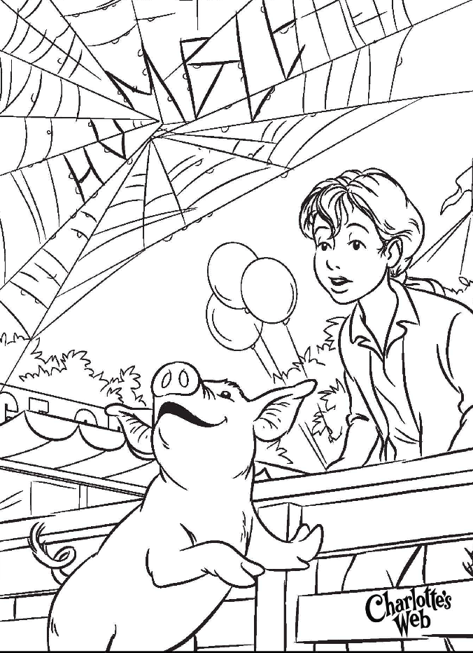

March is Reading Month is full of "Wacky Wednesday" Dress Up Days & Donut with Mom and Dad Celebration
**March Reading Month Incentive Program: Each Wednesday we will have sight word challenge test for 10 new sight words that your child can read from their sight word lists. And each week we will take a spelling test on 10 sight words from the first grade list in order. 10 a week. Prizes for students that can read 10 new words a week and spell 10 words from the first grade sight word list.
Week 1: Wednesday sight word test for spelling: the, and, a, you, of, I , his, she, on, but Bonus: was & said
Week 2: to, he, it, in, all, for, up had, at, with Bonus: they & that
Week 3: look, is, her, its, into, out, him, as, be, have, go Bonus: there & some
Week 4: by, over, your, ride, just, blue, four, here, saw, call Bonus: their & after
March is reading month- Whiting’s Web of Readers: Guest Readers: Our Guest Reader photos will be on our classroom door and on our classroom Weebly: http://tinawhiting.weebly.com/
Guest Readers:
Jacob’s mom is coming to kick off our celebration March 2nd and Ryan’s mom is coming over to read to us too!
Important Upcoming Dates:
March 2nd DR Seuss Birthday Party
March 3rd book fair 10:30
March 4th PJ or dress as a character day March is reading month kick off
March 11th Print day dress up. Animal prints or stripes, polka dots etc..
March 11th and 12th Parent Conferences day
March 12th and 13th ½ day
March 17th Walk to Library @ 1:00
March 18th America Day: Red, White and Blue
March 25th Wacky Day: Cray hair, clothes, mis-match or whatever strikes your fancy! Get Wacky
March 27th School Spirit Day Blue and White with donuts with mom and dad day
April 3rd-April 12th No School Spring Break – Please visit our public library over break!
April 13th return to school
May 22nd ½ day
May 25th -No School Memorial Day
June 9th & 10th ½ day Last day of school

Reading & Writing:
Charlotte’s Web: We are reading Charlotte’s Web focusing on character connections, setting of both time and place, main problem as well is small issues, easy solutions and life time consequences, and retelling sequence of events in each chapter.
Students are reading both fiction and nonfiction at their ability level daily. They are writing at least 3 facts about their nonfiction text and writing character, setting, problem and solution with connection for a fictional piece. We read independently 20 mins each morning. We read with a partner 5-10 mins each day. We listen to stories and answer questions and make connections daily. We are making text to text, text to self and text to world connections. Just ask us!
Sight Word Reading Challenge: We have a sight word challenge each Wednesday. Your child will bring home 10 sight words he/she is working on to become a great reader and writer, will be on the sight word list coming home each week. Your child brought home a list of words Friday. They will be tested Wednesday and given 10 new words to practice for next week’s challenge.
Come visit during reading time 9-10:45 and/or
Writing Time: 12:00-12:30
Writing: We are writing all genres of writing and knowing the difference in each: opinion, narrative and informational and we know what the success criteria is for each type of writing. Just ask us!
*Our new writing unit will consist of students knowing/reflecting on the difference between: Narrative/Opinion/Personal Expertise:
What you can do at home: Ask your child what type of writing he/she is working on this week. Ask your child for the success criteria for that type of writing. Write a piece at home that you can bring to share at school. Ask your child what is the success criteria for a personal expertise? What is the success criteria for opinion? What is the success criteria for narrative? These are very different and you are writing each for a different purpose.
Science & Social Studies: Citizenship writer’s presentations were amazing! The kids have been publishing writing pieces since kindergarten and their public speaking to peers is growing with great voice, expression and eye contact. They ask their peers great questions about their pieces presented and take and answer questions well. When we return from spring break, we will start out animal’s life unit for science.
Come Visit during Science/SS 12:30-1.
What you can do at home: Begin notice animals and insects appearing for spring. Notice their habitats and daily routines. Are these creatures nocturnal or diurnal? How can you tell? Could these creatures survive in a different environment? Could they survive is they were nocturnal instead of diurnal or vice versa? What do all creatures need to survive?
Mathematics:
We are creating place value for 100s; 10’s and 1’s. We are counting off the 10 and some more. 10 plus one more and 10 -1 less. We can move up and down the number line with ease off the 10 decade.
How you can help at home: ask your child how many ones are in 66, how many tens? Ask your child how many are in 103? How many hundreds? Tens? Ones? Ask your child how many 10s are in 100? How many ones? Ask your child if you are at 40 and have 8 more what would you have? If you are at 60 and have 13 more what would you have? If I am at 70 and now I have 5 less what would I have. I am at 120 and I have 20 less. What do I have. They love guess my number game and what is missing game. Stop in and we can show you how to play!
Come visit during math time and see our learning. 2:15-3:15
* We are finding flexibility with numbers and conceptual understanding in these math unit.
Classroom Needs: Clorox wipes, please send in a water bottle for your child to use each week.
Check out the class photos, events and newsletters on Weebly! http://tinawhiting.weebly.com/
Mrs. Whiting

